**EXERCISE 3**

You are approached by a hotel manager to help them gain insights about two resorts of which they have recently taken ownership: a City Resort and a Beach Resort. It is September 2017, and the manager noticed that since taking control on January 1, 2017, the total number of guests at the hotel has increased. **They want to understand if this increase is due to seasonality by comparing the total number of guests (monthly) from January 1, 2017 – August 31, 2017 with the same period in 2016.**

1. Create an Arrival Date calculated column with a datatype of date using the following fields: arrival_date_year, arrival_date_month, arrival_date_day_of_month
2. Create a date table. Join the date field on the date table with the Arrival Date field in the hotel_bookings table.
3. Create a calculated measure to calculate the total number of guests where the reservation was not cancelled. (Hint: include the counts of all adults, children, and babies. Only include rows where is_canceled = 0)
4. Use the calculated measure in a visualization showing the total number of guests by month from January 1, 2017 – August 31, 2017.
5. Create a time intelligence function to calculate the total number of guests for the same period in the previous year.
6. Add the time intelligence function to the previous visualization so the two periods can easily be compared. Refer to Figure 1 (see page 3 ) as an example.
7. Create a second visualization to see if this trend is the same for both the City Resort and the Beach Resort (Hint: use the hotel field). 2016 data is not required for this visual.
8. Create a tabular view of the visualization from part g. Use the bookmark functionality to set up toggling between the visual view and the tabular view. You may want to set up your bookmark(s) so only the selected visuals change when activated (refer to the below visual to refresh your memory). Assign the bookmarks as Actions to buttons and include these buttons on the report for an enhanced user experience.

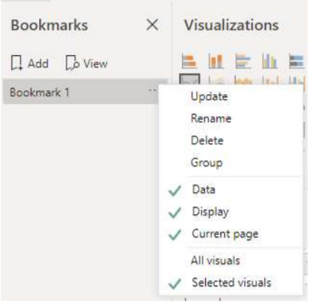

1. Publish the report onto your workspace and share it with class
2. Write a report on your observations

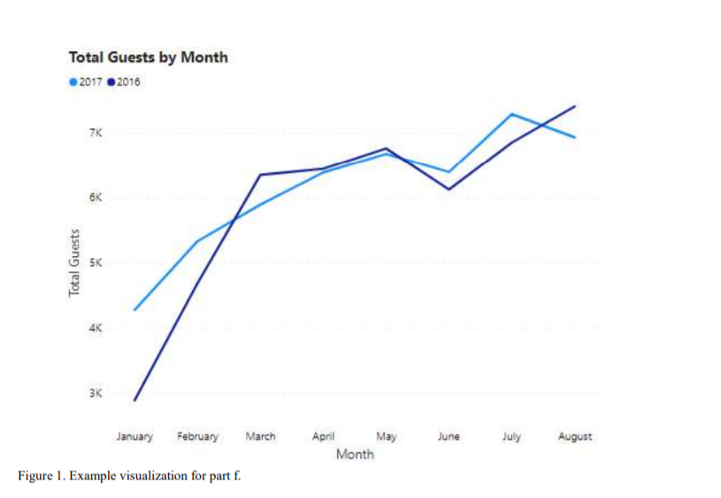

**Data Dictionary**

hotel

Hotel (H1 = Resort Hotel or H2 = City Hotel)

is_canceled

Value indicating if the booking was canceled (1) or not (0)

lead_time

Number of days that elapsed between the entering date of the booking into the PMS and the arrival

date

arrival_date_year

Year of arrival date

arrival_date_month

Month of arrival date

arrival_date_week_number

Week number of year for arrival date

arrival_date_day_of_month

Day of arrival date

stays_in_weekend_nights

Number of weekend nights (Saturday or Sunday) the guest stayed or booked to stay at the hotel

stays_in_week_nights

Number of week nights (Monday to Friday) the guest stayed or booked to stay at the hotel

adults

Number of adults

children

Number of children

babies

Number of babies

meal

Type of meal booked. Categories are presented in standard hospitality meal packages:

Undefined/SC – no meal package; BB – Bed & Breakfast; HB – Half board (breakfast and one

other meal – usually dinner); FB – Full board (breakfast, lunch and dinner)

country

Country of origin. Categories are represented in the ISO 3155–3:2013 format

market_segment

Market segment designation. In categories, the term “TA” means “Travel Agents” and “TO” means

“Tour Operators”

distribution_channel

Booking distribution channel. The term “TA” means “Travel Agents” and “TO” means “Tour

Operators”

is_repeated_guest

Value indicating if the booking name was from a repeated guest (1) or not (0)

previous_cancellations

Number of previous bookings that were cancelled by the customer prior to the current booking

previous_bookings_not_canceled

Number of previous bookings not cancelled by the customer prior to the current booking

reserved_room_type

Code of room type reserved. Code is presented instead of designation for anonymity reasons.

assigned_room_type

Code for the type of room assigned to the booking. Sometimes the assigned room type differs from

the reserved room type due to hotel operation reasons (e.g. overbooking) or by customer request.

Code is presented instead of designation for anonymity reasons.

booking_changes

Number of changes/amendments made to the booking from the moment the booking was entered

on the PMS until the moment of check-in or cancellation

deposit_type

Indication on if the customer made a deposit to guarantee the booking. This variable can assume

three categories: No Deposit – no deposit was made; Non Refund – a deposit was made in the

value of the total stay cost; Refundable – a deposit was made with a value under the total cost of

stay.

agent

ID of the travel agency that made the booking

company

ID of the company/entity that made the booking or responsible for paying the booking. ID is

presented instead of designation for anonymity reasons

days_in_waiting_list

Number of days the booking was in the waiting list before it was confirmed to the customer

customer_type

Type of booking, assuming one of four categories:

Contract - when the booking has an allotment or other type of contract associated to it; Group –

when the booking is associated to a group; Transient – when the booking is not part of a group or

contract, and is not associated to other transient booking; Transient-party – when the booking is

transient, but is associated to at least other transient booking

adr

Average Daily Rate as defined by dividing the sum of all lodging transactions by the total number of

staying nights

required_car_parking_spaces

Number of car parking spaces required by the customer

total_of_special_requests

Number of special requests made by the customer (e.g. twin bed or high floor)

reservation_status

Reservation last status, assuming one of three categories: Canceled – booking was canceled by

the customer; Check-Out – customer has checked in but already departed; No-Show – customer

did not check-in and did inform the hotel of the reason why

reservation_status_date

Date at which the last status was set. This variable can be used in conjunction with the

ReservationStatus to understand when was the booking canceled or when did the customer

checked-out of the hotel